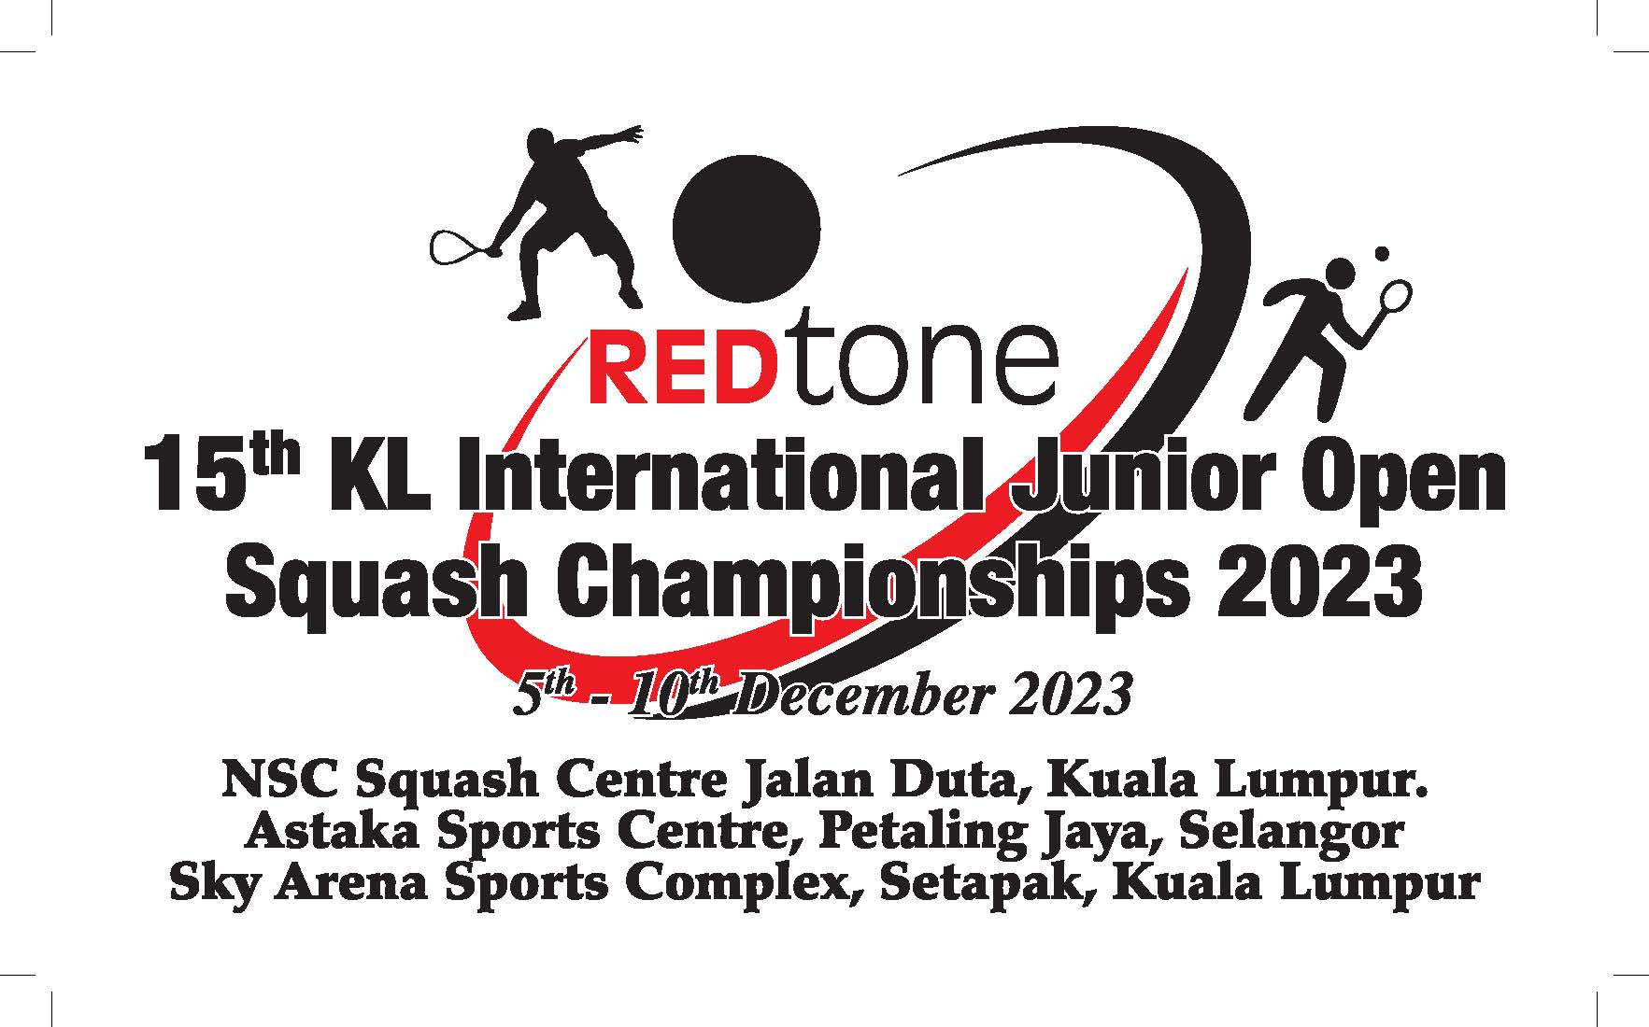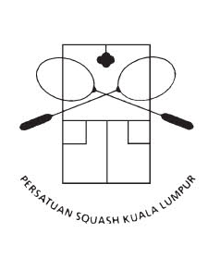

(5th Dec. – 10th Dec. 2023)
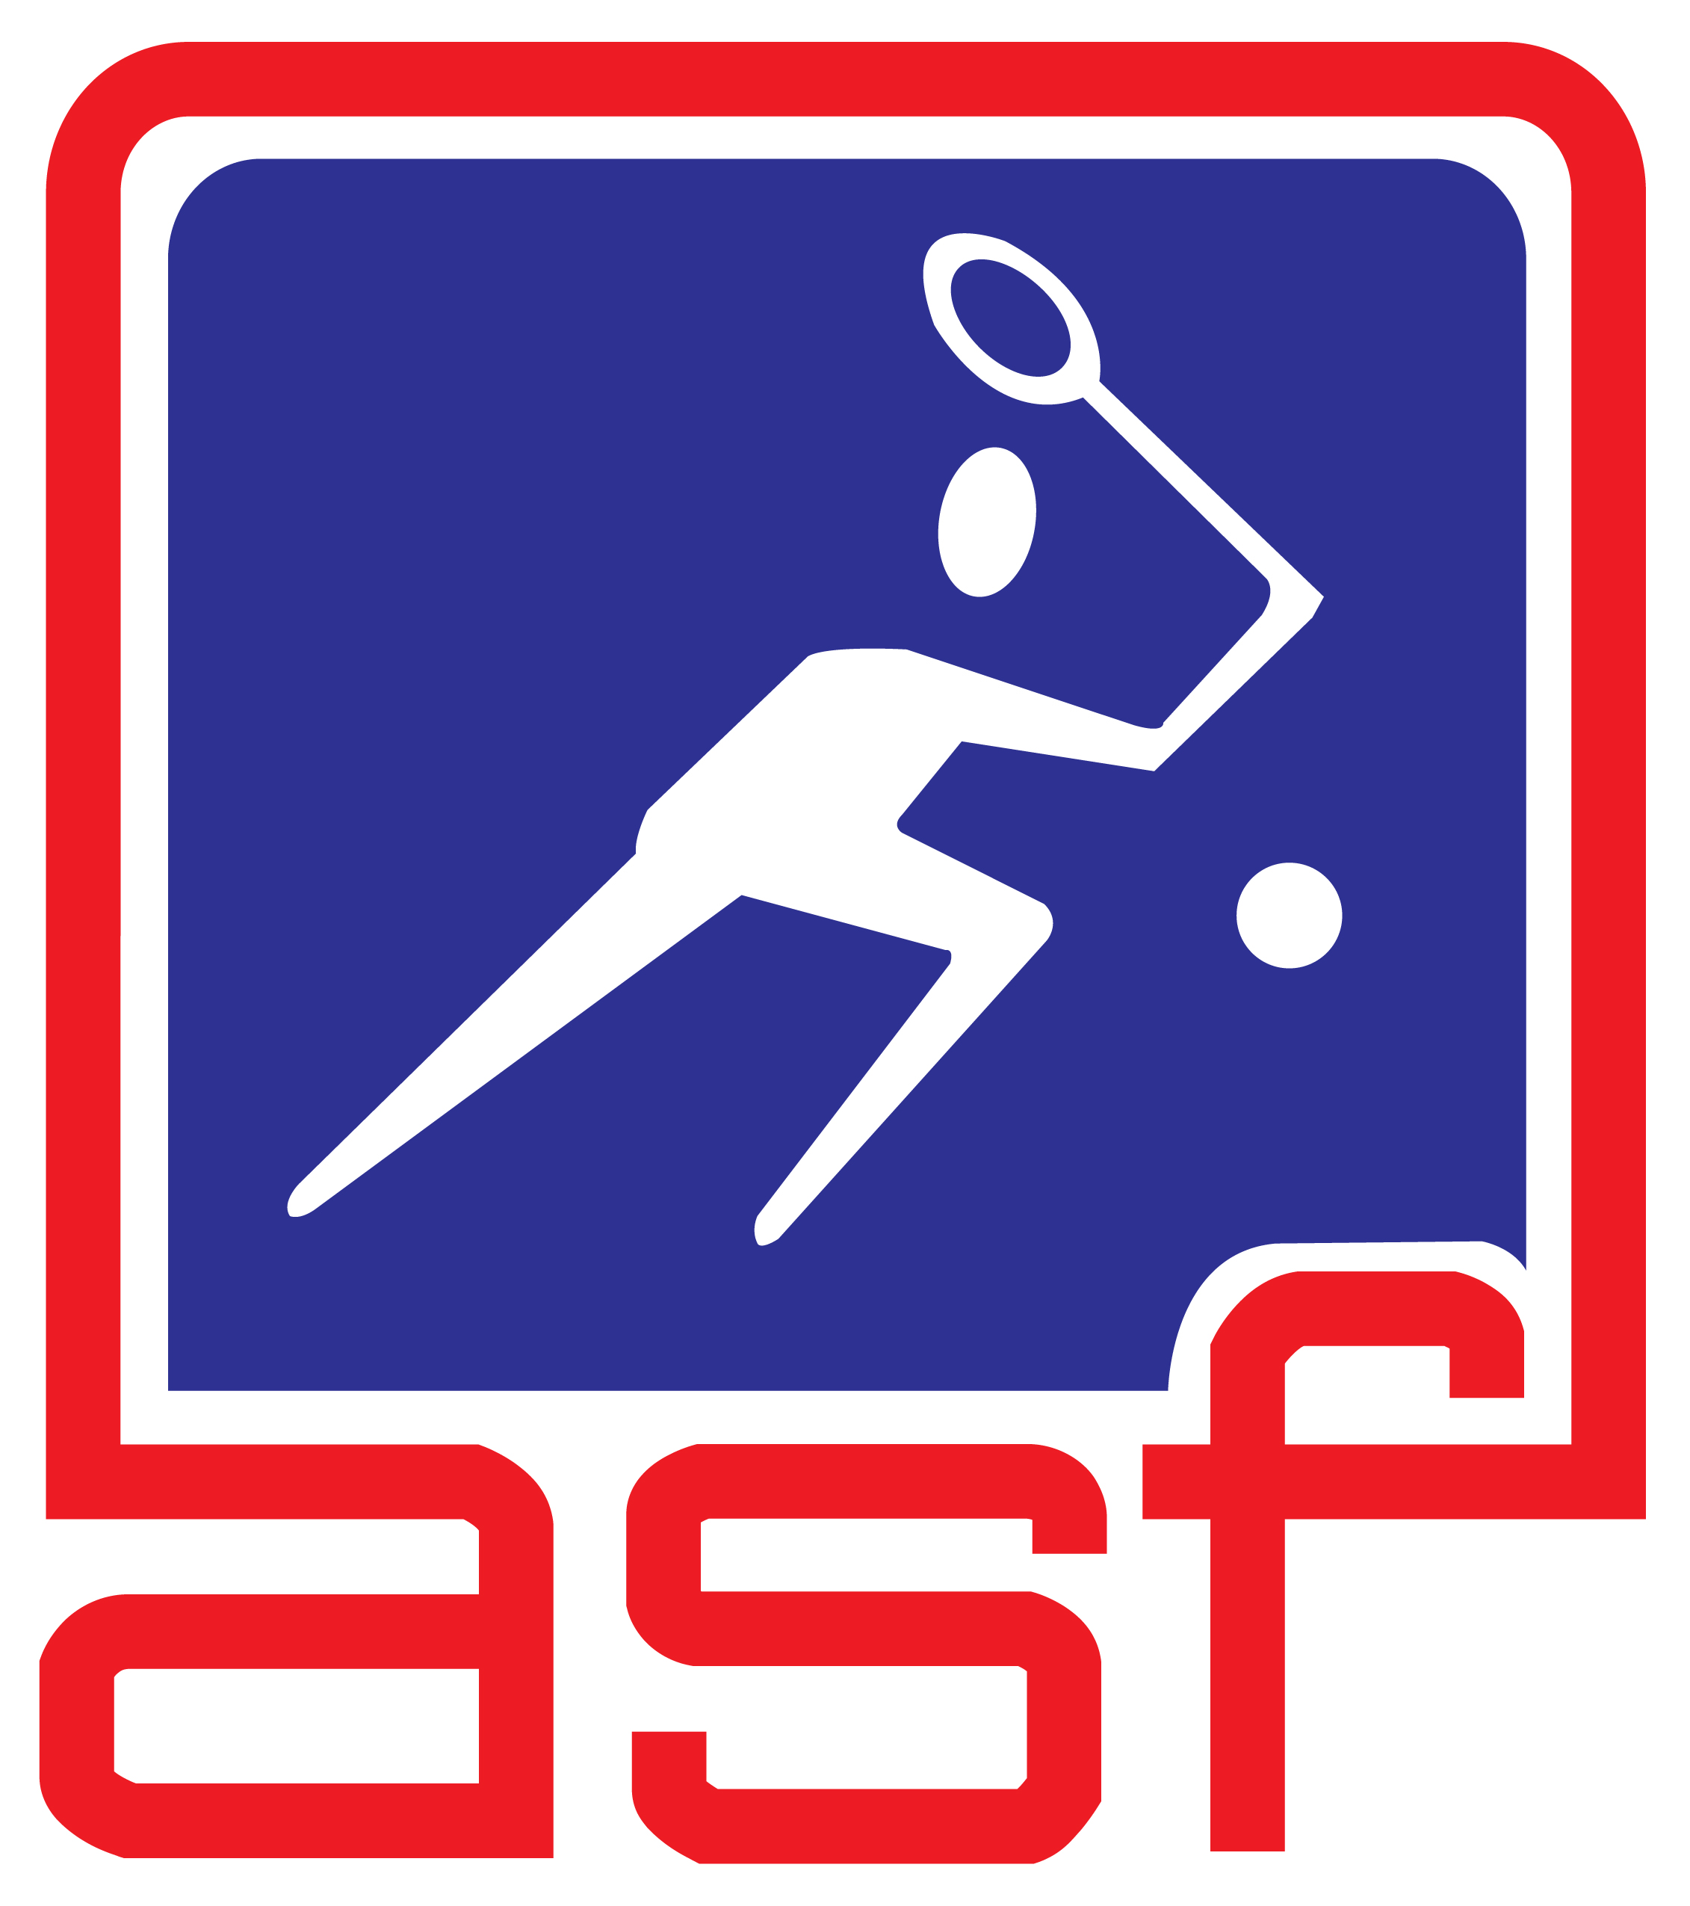 An Asian Junior Super Series 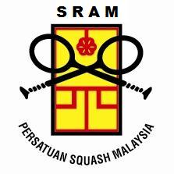
Platinum Event
(Sanctioned by ASF)

CHAMPIONSHIP INFORMATIONS

VENUE

* NSC SQUASH CENTRE, Persiaran Tuanku Syed Sirajuddin ( Persiaran Duta), Kuala Lumpur.

* ASTAKA SPORTS CENTRE, Petaling Jaya, Selangor Darul Eshan

* SKY ARENA SPORTS COMPLEX, Setapak, Kuala Lumpur.

* TOP 8 PLACING ALL AGE GROUPS:- NSC Squash Centre, Persiaran Tuanku Syed Sirajuddin
( Persiaran Duta), Kuala lumpur.

EVENTS

1. Boys under 9 Open Event 1. Girls under 9 Open Event

2. Boys under 11 Open Event 2. Girls under 11 Open Event

3. Boys under 13 Open Event 3. Girls under 13 Open Event

4. Boys under 15 Open Event 4. Girls under 15 Open Event

5. Boys under 17 Open Event 5. Girls under 17 Open Event

6. Boys under 19 Open Event 6. Girls under 19 Open Event

NOTE: BOYS AND GIRLS UNDER 9 ARE NOT ELIGIBLE FOR THE ASIAN JUNIORS RANKING POINT.
PLAYERS CAN ENTER ONE EVENT ONLY.

AGE CUT OFF DATE

* The age cut off date for the Championships is 10th December 2023

ENTRY

- It is open to all foreign and local players NOT banned by the ASF. All foreign/local player entries must be endorsed by their respective National/State Association. Please give your correct date of birth as we will verify them from your Passport. ENTRIES WITHOUT SPIN NUMBER WILL BE REJECTED.

ENTRY FEES

a. Foreign players (Without Accommodation) - USD 100 per person
b. Local - (Without Accommodation) - RM 140.00 per person

- Entries and Bank In slip to EMAIL to: Persatuan Squash WP Kuala Lumpur. ( sraft_kl@yahoo.com )
- Only payments made directly into the Account Number will be accepted.
- Please add in USD 25 each transaction as BANK CHARGES OVER HERE.
Persatuan Squash WP Kuala Lumpur
Account Number: 8000928820
Bank: CIMB SWIFT CODE: CIBBMYKL
Branch: The Scott Garden, Jalan Klang Lama, 58000, Kuala Lumpur
* SRAFT cannot be held responsible for entries not accompanied with payment.
* Purpose of payment must be stated properly.

PLAYER WITHDRAWAL

* Withdrawal from the Championship must be notified to SRAFT as soon as possible by telephone or email. Entry fees will not be refunded.

CLOSING DATE

* Entries must be received by 12.00pm NOON (M’sian time) on or before 15^{h} Oct. 2023

LATE ENTRIES OR ENTRIES WITHOUT THE ENTRY FEE WILL NOT BE ACCEPTED.

ACCOMMODATION (FOREIGN PLAYERS)

PACKAGE A

* Official Hotel – The Gardens Hotel & Residence, Mid Valley City, Lingkaran Syed Putra, 59200 Kuala Lumpur – 5 Stars*****

The package of USD 600 (per person) includes entry fee & 7 nights’ accommodation from 4th
- Dec (Mon) to 11th Dec (Mon) 2023, only on a twin sharing basis with breakfast for both officials and players. There will be NO REFUND for unused nights

- For the single room, the rate is USD 800 (per person) includes entry fee & 7 nights’ accommodation from 4th Dec to 11th Dec. 2023 with breakfast. There will be NO REFUND for unused nights.

- For additional night, foreign booking MUST also be made through the Organiser in order to enjoy the same rate and the charges per night as follows:
- Single = USD 100 per person per night with breakfast
- Twin Sharing = USD 50 per person per night with breakfast

- Only accommodation booked through PERSATUAN SQUASH WP KUALA LUMPUR will be provided bus shuttle services between the hotel and venue.
Package B

* The Pearl Hotel, Batu 5, Jalan Klang Lama, 58000 Kuala Lumpur – 4 Stars****

- The package of USD 400 (per person) includes entry fee & 7 nights’ accommodation from 4th Dec (Mon) to 11th Dec (Mon) 2023, only on a twin sharing basis with breakfast for both officials and players. There will be NO REFUND for unused nights.

- Local players RM 650 (per person) includes entry fee & 6 nights’ accommodation from Mon, 4th to 10th Dec (Sun) 2023, only on QUART SHARING basis without breakfast. There will be NO REFUND for unused nights.

- For the single room, the rate is USD 600 (per person –) includes entry fee & 7 nights’ accommodation from 4th Dec. to 11th Dec. 2022 with breakfast. There will be NO REFUND for unused nights.

- For additional nights, foreign booking MUST also be made through the Organiser in order to enjoy the same rate and the charges per night is as follows:

- Single = USD 60 per person per night with breakfast
- Twin Sharing = USD 30 per person per night with breakfast

- Only accommodations booked through PERSATUAN SQUASH WP KUALA LUMPUR will be provided bus shuttle services between the hotel and venue during tournament

AIRPORT TRANSFER – For foreign players & officials on Hotel package arrangement only

* All foreign players and officials will be picked up from the airport upon arrival. Transfer to Airport after the tournament will be also provided.
. Kindly provide details of the arrival and departure as per form attached.

TOURNAMENT T- SHIRTS

* All participants will receive one (1) Tournament T shirt.

TRANSPORTATION

* Shuttle services between official hotel and venues will only be provided for players/officials/parents,
who book their rooms through the Organiser only

OFFICIAL BALL

* Squash Ball – DUNLOP DOUBLE YELLOW DOT.

ORGANISER

- The Championship is organised by the Squash Racquets Association of Federal Territory, Kuala Lumpur (SRAFTKL)

- Sanctioned by Squash Racquets Association of Malaysia. (SRAM)

- A PLATINUM Asian Junior Super Series Event (AJSS)

TOURNAMENT ORGANISATION:

* Organizing Chairman Mr Steven Kwan Mobile Phone No: 012-3309226
A.M.N., A.M.W

Deputy Organizing Chairman Ir.Syed H Kebir Mobile Phone No. 0123290343

Tournament Director: YM Raja Razaman Mobile Phone No: 016-2711112

Asst. Tournament Director: Mr Vincent Lee Mobile Phone No: 0193530646

Tournament Referee: TBA

Secretariat: Puan Zahrah Yusof Mobile Phone No: 013-2582299
Puan Hajjah Noor Suria Mobile Phone No: 017-3762343
Encik Najmi Hafifi Hussain

Finance Puan Idayu Idris Mobile Phone No : 0137977089

Transportation Tuan Haji Ampandi Bin Omar Mobile Phone No: 012-3763343

Medical Dr Nirmala Ponnudurai Mobile Phone No: 012-3950604

SRAM Technical Delegate: TBA Mobile Phone No:

ENTRIES

- All players must complete an official entry form with the entry fee slip & fax to :

THE TOURNAMENT DIRECTOR,
(REDtone 15th KL Junior Open Squash Championships 2023)
E-Mail: sraft_kl@yahoo.com

(YM Raja Razaman - HP 016-2711112 / Vincent Lee-HP 0193530646)

Supported by:

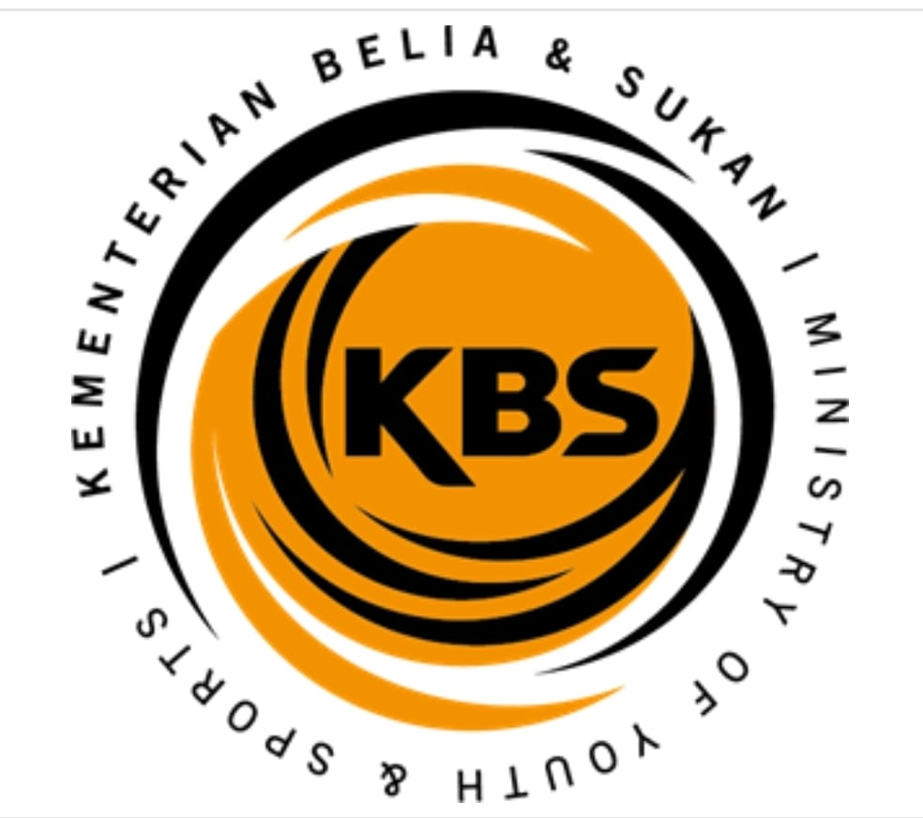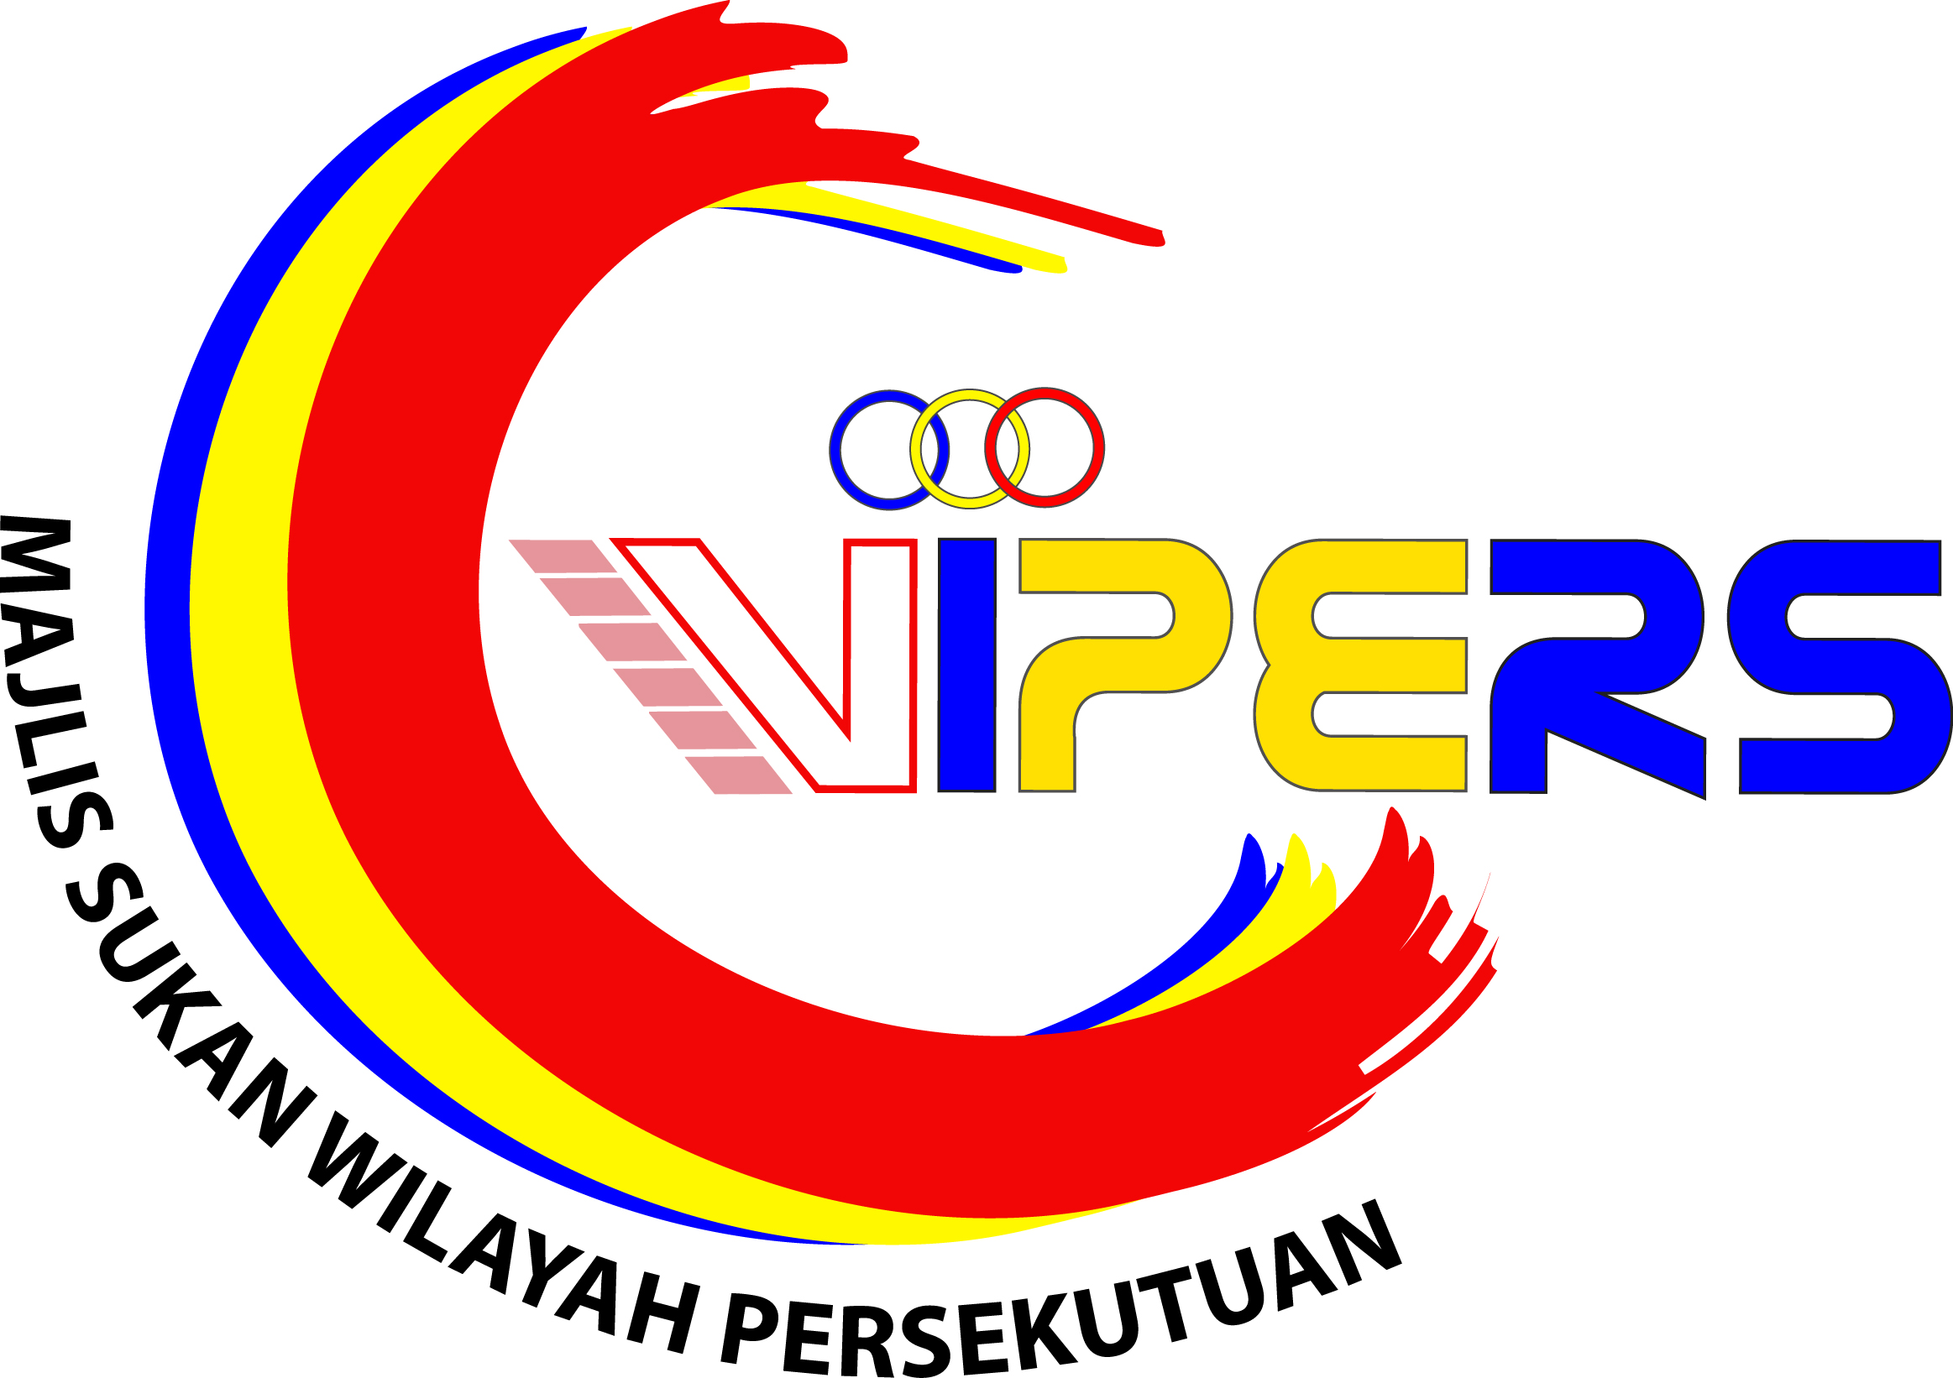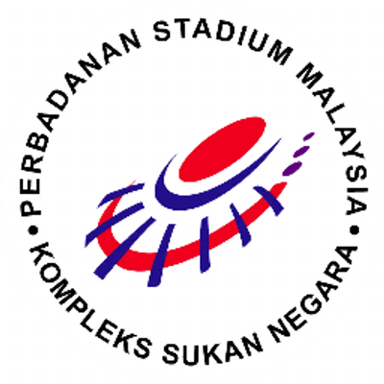

Notes to Participants

- Prizes in kind & medals will be awarded to all top 8 winners in all age Groups.
- Championships Date: 5th – 10th December 2023.

- Venue: NSC SQUASH CENTRE, Persiaran Jalan Duta, Kuala Lumpur.
ASTAKA SPORT CENTRE, Petaling Jaya, Selangor Darul Eshan.
SKY ARENA SPORT COMPLEX, Setapak, Kuala Lumpur.

TOP 8 PLACING FOR ALL AGE GROUPS WILL BE PLAY @

NSC SQUASH CENTRE, Persiaran Tuanku Syed Sirajuddin ( Persiaran Duta), Kuala Lumpur

- For all local players, this tournament may be considered as part of the National Junior Ranking by Squash Racquets Association of Malaysia (SRAM) for tournament grading for CIMB National Junior Circuit for 2024.

Rules

- All officials and players must ensure they are 15 minutes before their matches start.

- All players MUST check their next round matches before leaving the venue.

- Walkover will be given, if the player is late by 15 minutes by the time the name is called

- All players must mark and referee matches when required.

- All players must wear eyewear.

- The matches are base on circuit format. Winners of all rounds will play best of five. Loser will be best of 3. All players will play until they achieve their final positions. ALL top 8 positions will play best of 5 on the final day.

- The scoring format is 11 Points – PAR (Point-A-Rally) and following the WSF Rules of World Singles Game.

- The Organizing Committee reserves the rights to make changes to the format of play (if necessary) after the entry closes. The decisions shall be final.

REDtone 15th KL Junior Open 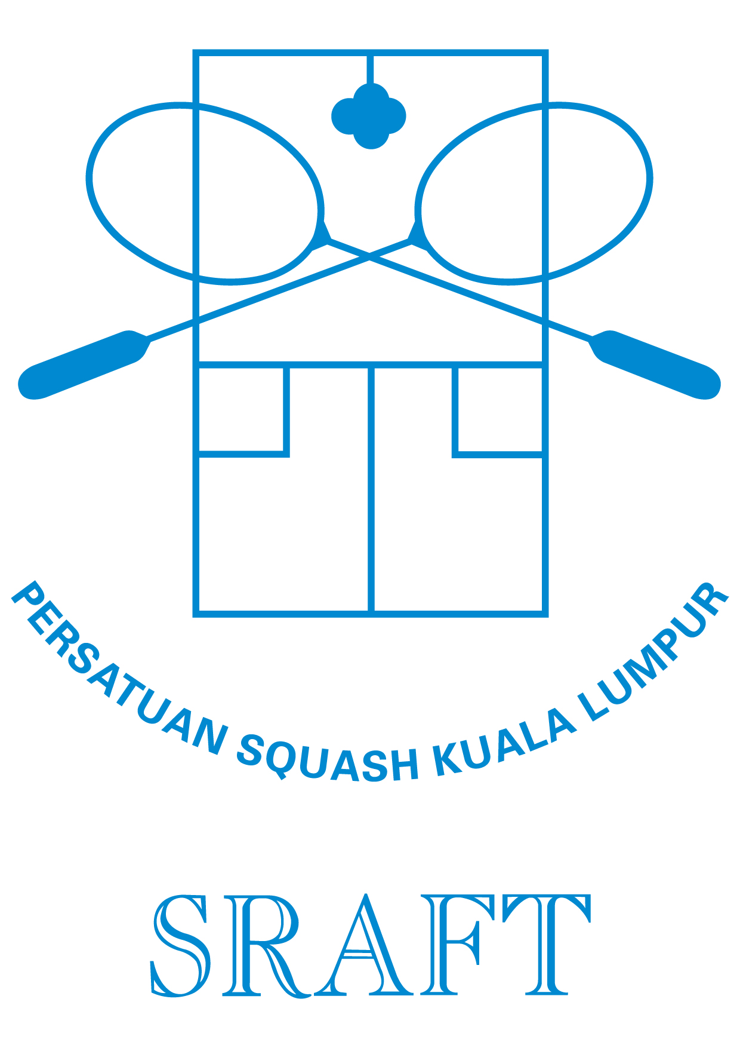
Squash Championships 2023
5th DEC – 10th DEC 2023

ARRIVAL AND DEPARTURE DETAILS

COUNTRY | :
ARRIVAL DATE | : |  |  |  |  | TIME |  | :
FLIGHT NO | : |  |  |  |  | AIRLINE |  | :
MANAGER | :
COACH | :
PLAYERS | :
DEPARTURE DATE |  | : |  |  |  | TIME |  | :
FLIGHT NO |  | : |  |  |  | AIRLINE |  | :
NO OF PAX |  | :

Kindly email to:

PERSATUAN SQUASH WP KUALA LUMPUR

Email: sraft_kl@yahoo.com not later than 1st Nov 2023

ASF Code of Conduct

The following offences may be subject to penalties under Rule 17 of the International Singles Game of Squash and of the International Doubles Game of Squash, and/or be subject to disciplinary action by the ASF Disciplinary & Appeals Committee:
AB1. A participant who verbally or physically abuses his opponent, the Marker, Referee, officials, spectators or sponsors.

AB2. A participant who shows dissent to the Marker, Referee or officials, including foul or profane language and obscene or offensive gestures.

AB3. A participant who abuses playing equipment or the court.

AB4. A participant who fails to comply with the conditions of entry of a championship including any rules with regard to clothing or advertising.

AB5. A participant who having entered a championship or accepted an invitation to play withdraws from the event or fails to attend.

AB6. A participant who fails to complete a match for a reason other than injury, illness or emergency situation.
AB7. A participant who defaults from a championship. The Disciplinary & Appeals Committee may require evidence or proof of ‘bona fide’ injury, illness or another emergency situation.

AB8. A participant who fails to make himself available to meet reasonable request for interviews by the media.

AB9. A participant who does not comply with the Rules or spirit of the Game.

AB10. A participant guilty of any other unreasonable conduct which brings the Game into disrepute, including behavior as a result of intoxication by any means including recreational substances such as alcohol, marijuana and hallucinogens.

ASF CLOTHING REGULATIONS

The following clothing regulations shall apply without exception to all ASF Championships.

1. In all matters of judgment or opinion arising from the interpretation of this clothing rule the decision of the Championship Referee shall be final, except that he may not rule illegal or unacceptable an item of clothing or a design which has been approved by the ASF.

2. Playing clothing for men shall consist of a short-sleeved shirt, shorts, socks and playing shoes. Playing clothing for women shall consist of a shirt worn with a skirt or shorts, or a dress, socks and playing shoes. Other garments, such as part or all of a tracksuit, may be worn during play with the permission of the referee.

3. All clothing worn during practice as well as during match play shall conform to the accepted standards of decency and cultural/religious tradition of the Host Country, as adjudged by the Championship Referee.

4. For any match covered by television, players’ clothing shall conform to the advertising regulations published and generally applied by the appropriate television authority of the Host Country.

5. Players may wear clothing of any color or combination of colors.

6. Shirts or tops may carry:
a. The manufacturer’s normal trademark, symbol or name on one breast - the display to be contained within an area not exceeding 20 square centimeters in total and 10 centimetres in any one dimension.
b. Identification, in areas clearly separated from each other, on the opposite breast to the manufacturer’s symbol and/or on each arm, as follows:
i) Three sponsors’ displays - each to be contained within an area not exceeding 40 square centimetres in total and 10 centimetres in any one dimension;
OR
ii) Two sponsors’ displays and one national identification badge - each to be contained within an area not exceeding 40 square centimetres in total and 10 centimetres in any one dimension.
c. A national or club identification title, plus a sponsor’s identification if required, on the back of the shirt or dress; the whole to be contained within an area not exceeding 300 square centimetres. The player’s name may also be displayed within an area not exceeding 150 square centimetres.

7. Shorts or skirts shall be of design normally approved and used for Squash.

8. Shorts or skirts may carry:

a. The manufacturer’s normal trademark, symbol or name on one side or leg, contained within an area not exceeding 10 square centimetres in total.
b. One sponsor display on the opposite side or leg from that in F8a, contained within an area not exceeding 20 square centimetres in total and 10 centimetres in any one dimension.

9. Socks shall be of any color or combination of colors and each may carry one manufacturer’s normal trademark, symbol or name contained within an area not exceeding 10 square centimetres in total and 10 centimetres in any one dimension.

10. Shoes shall be of any colour or combination of colors and have a non-marking sole. Each shoe may carry one manufacturer’s normal trademark, symbol or name in not more than two areas, not exceeding in total 10 square centimetres.

11. Tracksuits may be of any design and colour and are subject to no advertising restrictions, unless worn during play when the restrictions under F6 above shall apply to the jacket and under F8 above shall apply to the trousers.

12. The wearing of headwear is permitted provided it is not so conspicuous or brightly reflective as to distract or insight an opponent and shall not be pinned in a potentially dangerous manner. Headbands and straps for approved protective eyewear may carry one manufacturer’s normal trademark totally contained within an area not exceeding 40 square centimetres or 10 centimetres in any one direction.

13. Wristbands may carry one manufacturer’s normal trademark totally contained within an area not exceeding 10 square centimetres.

14. Any jewellery or watches worn by a player shall not be so conspicuous or so brightly reflecting as to distract or unsighted an opponent and shall not be potentially dangerous.

15. The sponsor(s) of any tournament shall have no automatic right of exposure on a player’s clothing unless such exposure is stipulated on the entry form.

16. Where the manufacturer of clothing is also the sponsor of the player or team wearing the clothing, he shall additionally be allowed to utilize some or all of the advertising space granted to sponsors.

17. MNAs are advised to ensure that their contracts with individual players specify that selection will require the use of national team kit in team events and that players’ personal sponsors have no right of exposure on such kit.

